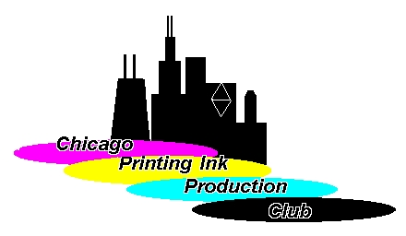

MEMBERSHIP APPLICATION

NAME: _______________________________________________________

COMPANY NAME: _____________________________________________

COMPANY ADDRESS: __________________________________________

________________________________________________________________________________

PHONE: __________________________________ FAX: _______________________

COMPANY WEBSITE: _____________________________________________________

Mailing address: __________________________________________________
(If different from Company address)
E-MAIL _________________________________________________

IS THIS AN ADDRESS CHANGE? YES: ______ NO: ______

Annual Membership: $60.00 CHECK #: ________________ DATE: ____________
TAX I.D. E5688-496-3

Please return this form with your check made payable to the
“CHICAGO PRINTING INK PRODUCTION CLUB”
To erik@producerschemical.com OR US MAIL
Erik Olson
4205 Onyx Court
Valparaiso IN 46385

If paying by credit card include the following:

Name on Credit Card:
Pay By: Visa____ Master Card_____ American Express_____ (please check one)
Card #: _____________________________________________________
Expiration Date: ______________________________________________
Total Amount to Charge: _______________________________________

